MAWLANA BHASHANI SCIENCE AND TECHNOLOGY UNIVERSITY
SANTOSH, TANGAIL-1902



DEPARTMENT OF INFORMATION AND COMMUNICATION TECHNOLOGY
Lab Report

Lab Report No : 08
Lab Report on : Working with JSON and Third-Party APIs Using JavaScript: Implementation
and Postman Testing
Course Title : Web Application Development Lab
Course Code : ICT-3204
Submitted By | Submitted To
Name: Kuldip Saha Mugdha  ID: IT-22018  3rd Year, 2nd Semester  Session: 2021-2022  Dept. of ICT, MBSTU | Mr. Md. Anowar Kabir  Lecturer  DEPARTMENT OF INFORMATION AND COMMUNICATION TECHNOLOGY  MAWLANA BHASHANI SCIENCE AND TECHNOLOGY UNIVERSITY

Date of Performance: 12/01/26 Date of Submission: 18/01/26
Introduction:
Modern web applications frequently interact with external services through Application Programming Interfaces (APIs). APIs allow applications to exchange data in structured formats such as JSON, enabling dynamic content generation and validation services. In this lab, JavaScript is used to access and process JSON data, test third-party APIs using Postman, and develop a simple web interface that provides user feedback based on API responses. This lab demonstrates practical skills in API testing, JSON handling, and client-side web development.

Objectives:
The main objectives of this lab are:
- To understand the structure and usage of JSON files
- To access and manipulate JSON data using JavaScript
- To install and use Postman for API testing
- To test Email Reputation and Weather APIs
- To display API responses in JSON format using JavaScript
- To develop a web page that provides feedback based on user input and API responses.

Tools and Technologies Used:
- HTML5
- CSS3
- JavaScript (ES6)
- JSON
- Postman API Testing Tool
- Email Reputation API (Abstract API)
- Weather API
- Web Browser (Google Chrome)

Procedures:
Step 1: Creating and Accessing a JSON File
A meaningful JSON file was created containing student information. JavaScript was used to read and display the JSON data in the browser console.
Source Code:
Sample JSON File (student.json)
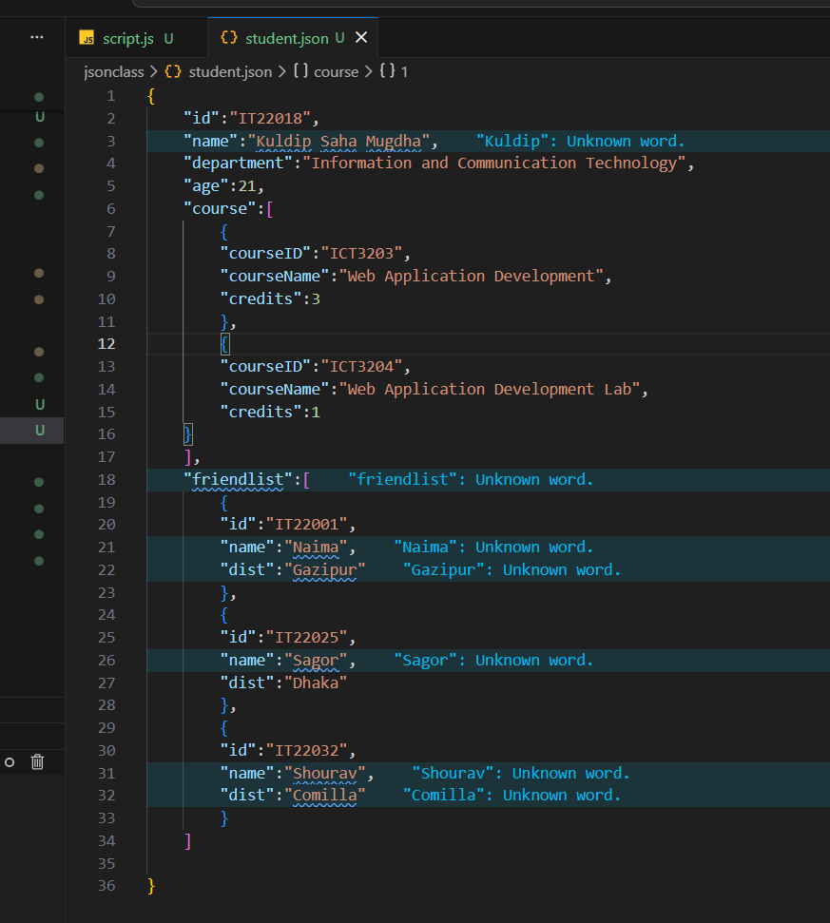

JavaScript to Access JSON File (script.js)
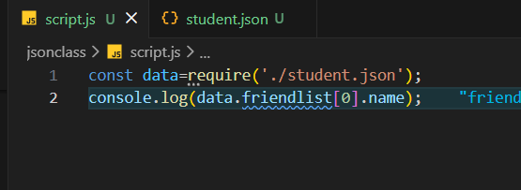
Output:
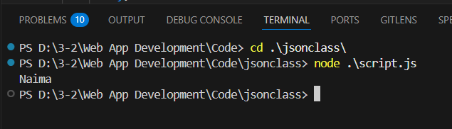

Step 2: Installing Postman
Postman software was downloaded from the official website and installed. It was used to test API endpoints by sending HTTP GET requests and analyzing JSON responses.
Step 3: Testing Email Reputation API
The Email Reputation API was tested in Postman by passing an email address and API key as query parameters. The API response was checked to determine whether the email was deliverable.

Source Code:
JavaScript Code to Test Email API
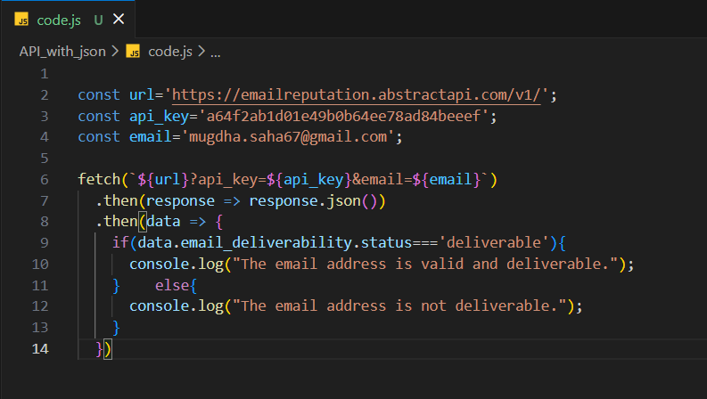
Postman Response:
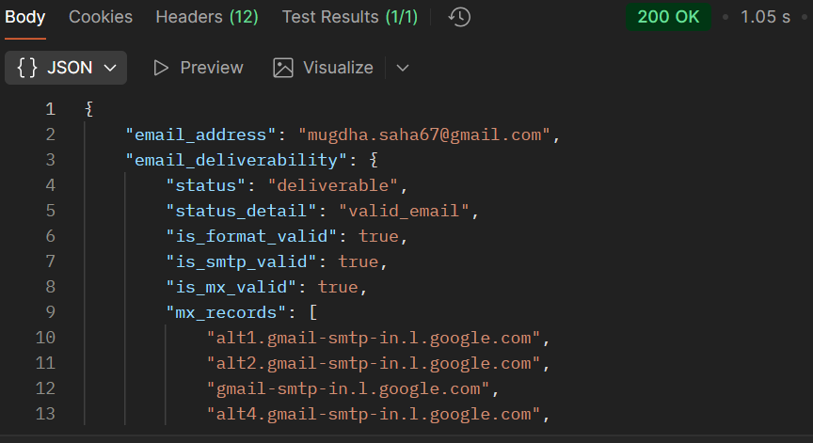
Step 4: Testing Weather API
The OpenWeatherMap API was tested in Postman using a city name and API key. Weather information such as temperature and condition was returned in JSON format.
Source code:
JavaScript Code to Test Weather API
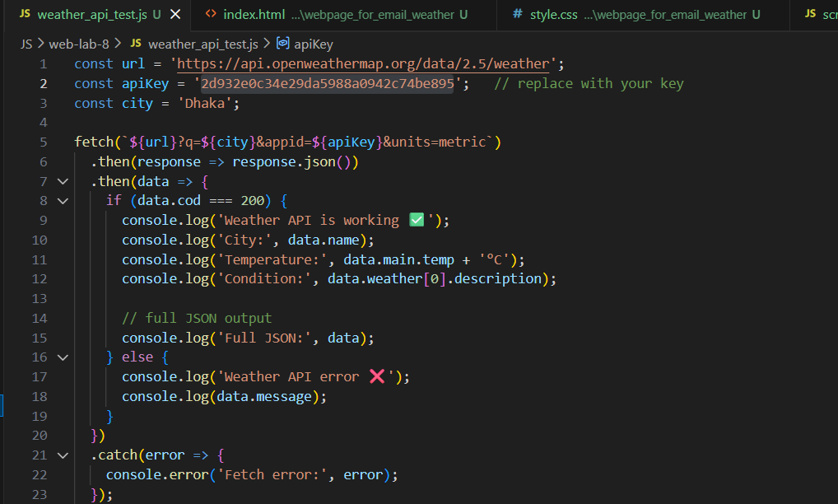
Postman response:
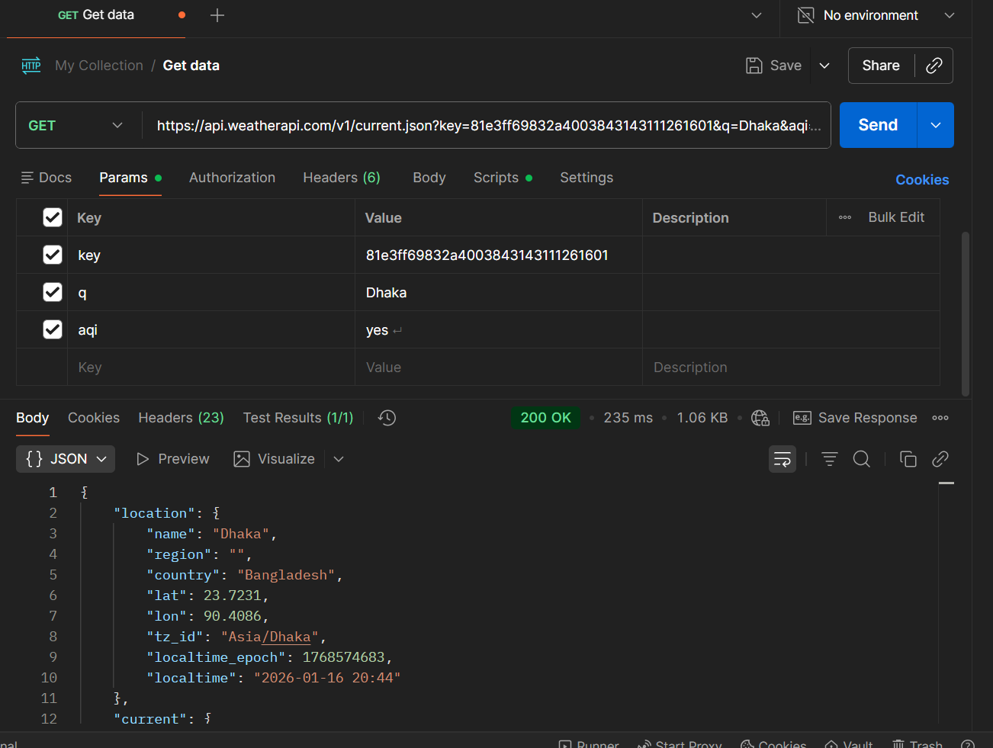
In browser:
https://api.weatherapi.com/v1/current.json?key=81e3ff69832a4003843143111261601&q=Dhaka
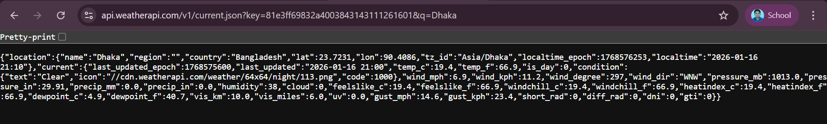

Step 5: Displaying API JSON Data Using JavaScript
JavaScript fetch() was used to retrieve API responses and display full JSON data in the browser console.
Source Code:
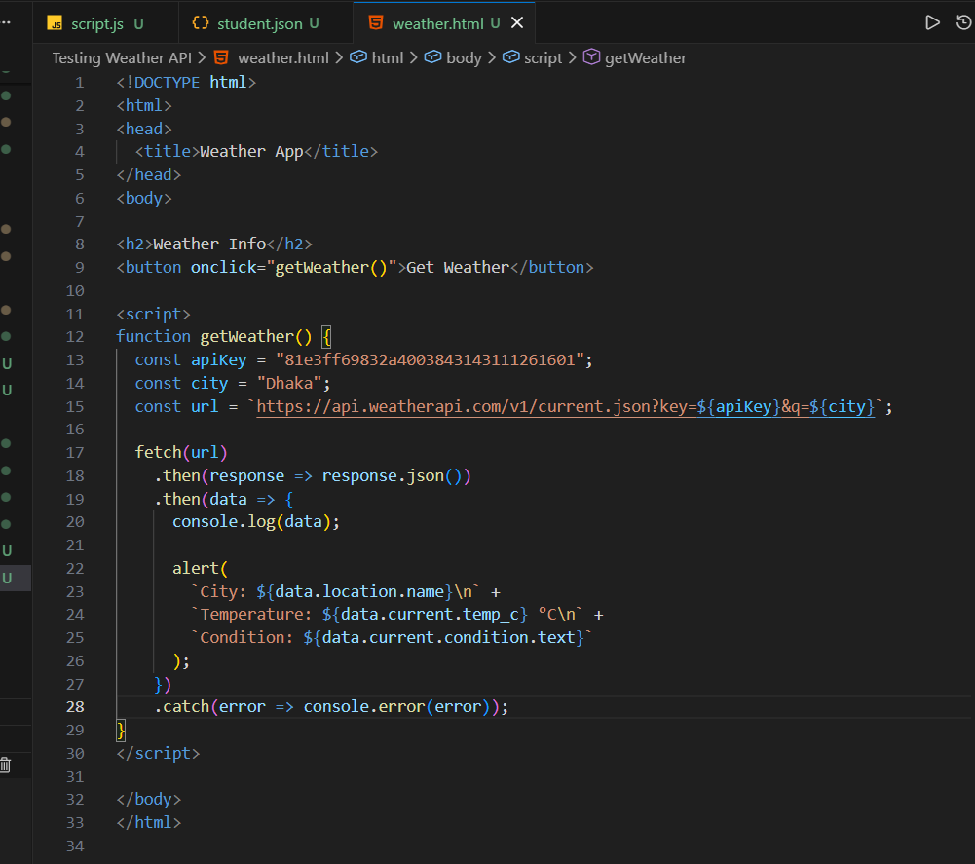
Output:
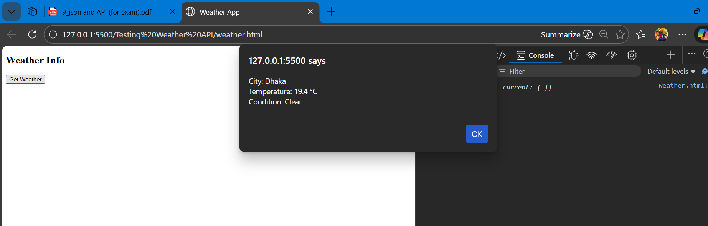

Step 6: Developing a Web Page for Email and Weather Feedback
A web page was developed where users can:
- Enter an email address to check deliverability
- Enter a city name to view weather information
The page provides separate feedback for each input based on API responses.
Source Code
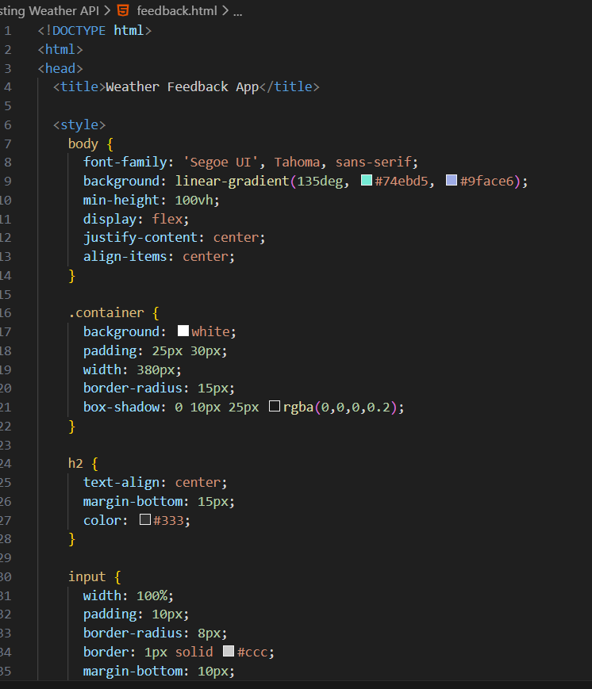
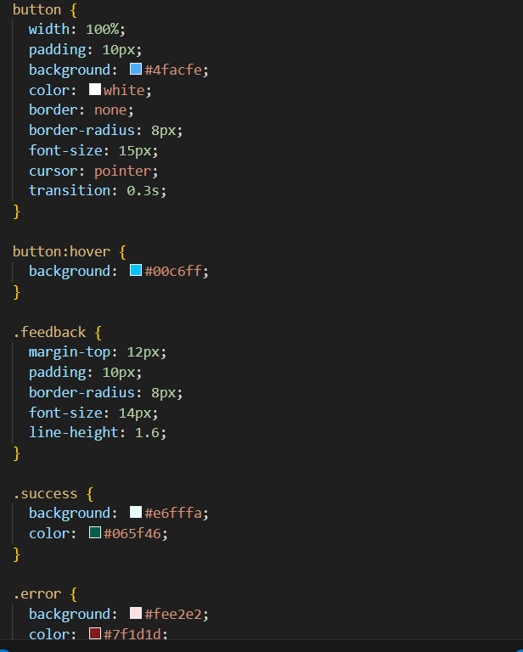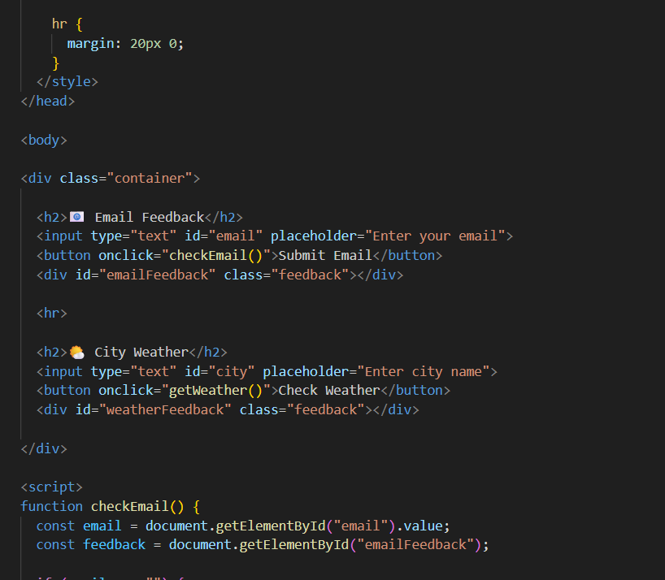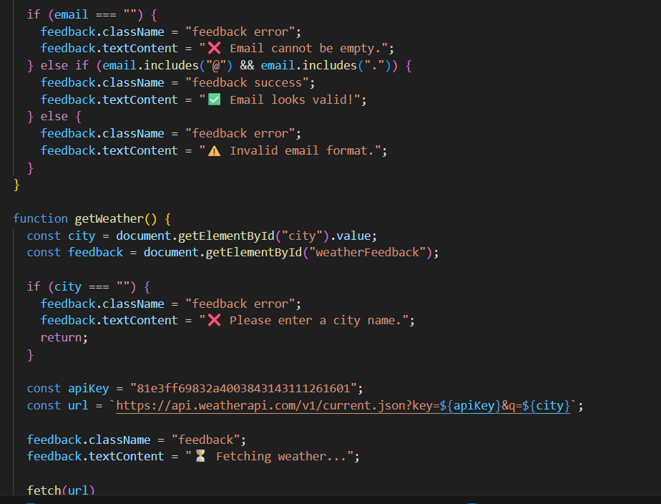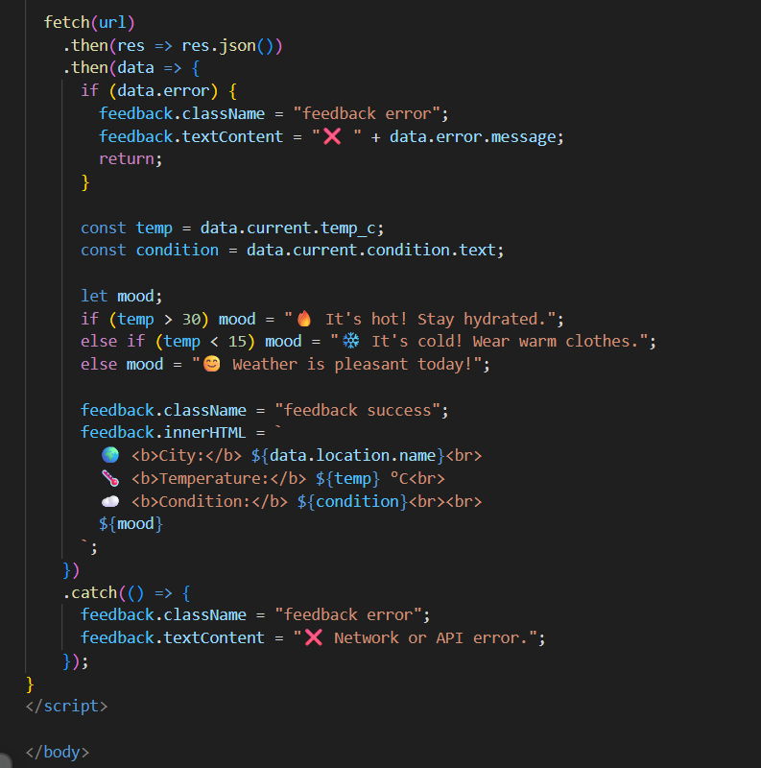
6. Output Screenshots:
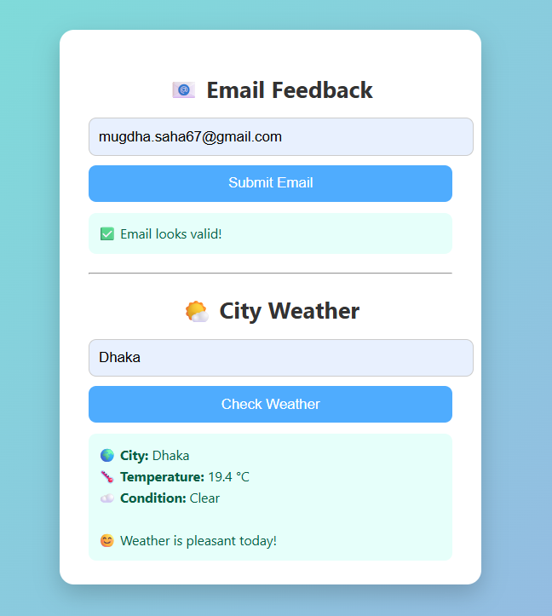

Conclusion:
In this lab, JSON data handling, API testing, and web-based user interaction were successfully implemented using JavaScript and Postman. The Email Reputation and Weather APIs were tested and integrated into a web interface that provides real-time feedback based on user input. This lab enhanced practical understanding of REST APIs, JSON structures, and client-side development, which are essential skills for modern web and software engineering applications.

